Section 1: Case Summary

Scenario Title: | Severe Pediatric Asthma Exacerbation
Keywords: | Pediatric, Asthma, Airway Management
Brief Description of Case: | A 5-year-old male with a history of asthma presents with a three-days of cough, wheeze and worsening shortness of breath. The team must recognize severe asthma and initiate usual asthma treatment, but the child does not respond to these basic treatments and continues to worsen. The team should escalate management – epinephrine, magnesium, ketamine. The patient continues to tire and requires intubation. Post-intubation, the team must optimize ventilator settings/paralyze/bear hug. If not treated aggressively, the patient will become hypotensive and increasingly hypoxic potentially leading to arrest.

Goals and Objectives
Educational Goal: | To expose learners to severe asthma in the pediatric patient
Objectives:  (Medical and CRM) | - Displays leadership by maintaining calm demeanor during crisis and acting decisively  - Employs good communication skills by using closed loop, listening to the input of others, and addressing concerned family members  - Implements the basic ED treatment of asthma  - Recognizes refractory/severe asthma and institutes appropriate treatments  - Recognizes need for and demonstrates ability to intubate the pediatric asthma treatment  - Manages post-intubation ventilation settings and appropriate sedation
EPAs Assessed:

Learners, Setting and Personnel
Target Learners: | ☐ Junior Learners |  | ☒Senior Learners |  |  | ☐ Staff
 | ☐ Physicians | ☐ Nurses |  | ☐ RTs | ☐ Inter-professional
 | ☐ Other Learners:
Location: | ☒ Sim Lab |  | ☐ In Situ |  |  | ☐ Other:
Recommended Number of Facilitators: | Instructors: 1
 | Sim Actors: 1
 | Sim Techs: 1

Scenario Development
Date of Development: | 11/11/2017
Scenario Developer(s): | Eve Purdy
Affiliations/Institutions(s): | Queen’s University
Contact E-mail: | epurdy@qmed.ca
Last Revision Date:
Revised By:
Version Number:

Section 2A: Initial Patient Information

- Patient Chart
Patient Name: Charlie Jansen |  |  |  | Age: 5 years | Gender: M | Weight: 25 kg
Presenting complaint: Shortness of Breath
Temp: 37.8 | HR: 160/min | BP: 80/50 |  | RR: 40/min | O₂Sat: 99% NRB | FiO₂:
Cap glucose: 6.2 mmol/L |  |  |  | GCS: 15
Vignette to read aloud before the start of the case: A 5-year-old boy arrives via EMS with increased work of breathing. He has known asthma and has been using his puffer more over the past 3 days. He has been given 2.5mg of nebulized salbutamol on route with paramedics. Current vitals are: HR 160, BP 85/60, RR 40, O2 98 % on NRB, Temp 37.8 He has some ongoing wheeze noted by EMS.

Triage note:
Increasing wheeze and shortness of breath over the past 3 days. Worsening today not relieved by puffers. Single dose of nebulized salbutamol with EMS. Appears unwell.

Allergies: none
Past Medical History:  Asthma – last steroids was last winter  Eczema  Hospitalized x 1 week @ 10 months with bronchiolitis |  |  | Current Medications:  Flovent  Ventolin

Section 2B: Extra Patient Information

A. Further History
Include any relevant history not included in triage note above. What information will only be given to learners if they ask? Who will provide this information (mannequin’s voice, sim actor, SP, etc.)?

Additional History to be provided by Father/Mother (sim actor): See below
Social History: Lives with parents
Family History: Mom and dad both have asthma and eczema

ROS: HEENT: Rhinorrhea, other normal, Resp: Decreased AE, Audible wheeze
B. Physical Exam
Cardio: Normal HS, no murmurs | Neuro: Alert. Oriented. Appears scared.
Resp: audible wheeze. Chest tight. Tracheal tug. Intercostal indrawing. ++ increased work of breathing | Head & Neck: Nil.
Abdo: Nil. | MSK/skin: Nil.
Other: Nil.

Section 3: Technical Requirements/Room Vision

A. Patient
☒ Mannequin (Pediatric)
☐ Standardized Patient
☐ Task Trainer
☐ Hybrid
B. Special Equipment Required
Monitors: EKG Leads/Wires, NIBP Cuff, Pulse Oximeter, Temperature Probe, Defibrillator Pads
Equipment: Gloves, Stethoscope, IV Bags/Lines, IV Push Medications, Nasal Prongs, Venturi Mask, Non-rebreather Mask, Bag Valve Mask, Laryngoscope, ET Tubes, Needle cric supplies, Peds NRB, PEEP Valve

C. Required Medications
Methylprednisolone, Normal Saline, Salbutamol, Ipratropium, Epinephrine, Magnesium Sulfate, Ketamine, Rocuronium

D. Moulage
None

E. Monitors at Case Onset
☐ Patient on monitor with vitals displayed
☒ Patient not yet on monitor

F. Patient Reactions and Exam
Include any relevant physical exam findings that require mannequin programming or cues from patient
(e.g. – abnormal breath sounds, moaning when RUQ palpated, etc.) May be helpful to frame in ABCDE format.

Airway: Nil
Breathing: Increased WOB, decreased air entry bilaterally, audible wheeze
Circulation: Normal heart sounds, afebrile
Disability: Moving all 4 limbs, GCS 15

Section 4: Sim Actors and Standardized Patients

Sim Actors and Standardized Patient Roles and Scripts
Mother/Father | Mother or Father will come in shortly after the patient arrives. They will help answer any further history questions.  HPI: He has known asthma and has been using his puffer more over the past 3 days.  Past Medical History: asthma – last steroids was last winter, eczema, hospitalized x 1 week @ 10 months with bronchiolitis  Current Medications: Ventolin, Flovent  Allergies: none  Social History: Lives with parents  Family History: Mom and dad both have asthma and eczema  ROS: HEENT: Rhinorrhea, other normal, Resp: today coughing, audible wheezing, with difficulty breathing  As the Charlie gets more sick, the mother/father will remain at bedside and become more agitated unless they are consoled.  Mother/father will notice Charlie getting sleepier and ask “Why does he look so tired”  After intubation/ROSC mother/father should be updated by a team member. If not, she will become upset.

Section 5: Scenario Progression

Scenario States, Modifiers and Triggers
Patient State/Vitals | Patient Status | Learner Actions, Modifiers & Triggers to Move to Next State |  | Facilitator Notes
1. Baseline State  Rhythm: NSR  HR: 160 bpm  BP: 80/50  RR: 40/min  O₂SAT: 99%NRB  T: 37.8ºC  GCS: 15 | Significant work of breathing.  Mother concerned at bedside. | Expected Learner Actions  Team inappropriate PPE  Monitors, O2, IV access  Methylprednisolone (1 –2mg/kg)  IV NS bolus (20 cc/kg)  Salbutamol (5 mg) and Ipratropium (0.5 mg) nebs x 3  IV MgSO4 (50 mg/kg)  Cap glucose  Portable CXR | Modifiers  - NS bolus HR 130 BP 85/55  - Mother not consoled increasing agitation/ obstructive  Triggers  - Nebs/steroids/Mg Next Phase  - 5 minutes Next Phase | Consider involving Social Work/Child Life Specialist depending on availability
2. Worse Dyspnea  HR: 140  BP: 80/50  RR: 45  O₂SAT: 96% neb  GCS: 13 (E3V4M6) | Patient complaining of worsening shortness of breath, more confused and unable to answer even simple questions | Expected Learner Actions  IM epinephrine (0.01mg/kg/dose)  Order labs, CXR, VBG  Start IV epinephrine infusion at (0.1mcg/kg/min)  Consider ketamine (2mg/kg bolus followed by 2mg/kg/hr)  Salbutamol infusion  Consider Heliox | Modifiers  - VBG 2 min later give result  - Epinephrine BP to 90/60  Triggers  - Epi infusion started and MGSO4 given fatigue  - 5 minutes or none of the above interventions fatigue | Nebulized MGSO4 (2.5ml) may be considered, though the evidence is weak.
3. Fatigue  HR: 150  RR: 12  BP: 75/50  O₂SAT 88%  GCS: 10 (E2V3M5) | Patient becomes more unresponsive, confused, and tired appearing. Decreased resp effort.  Mom asks why he looks so tired | Expected Learner Actions  Prepare for intubation  Call Anesthesia/Peds ICU (depending on leader)  Push-dose Epi OR increase infusion rate  Confirm tube placement  Ventilation settings articulated for permissive hypercapnia | Triggers  - Intubation post-intubation hypotension  -No intubation > 3 minutes progressive hypoxia (from decreased resp rate) bradycardia, arrest | Consider whether to paralyze or not given the ventilation needed to counteract the acidosis  Ventilation settings for permissive hypercapnia: Low TV and RR allowing for long I:E time
4. Post-intubation Hypotension  HR 130  O₂SAT 90%  RR as per bagging rate  BP 60/30  **Vent Alarms** | Difficulty to bag | Expected Learner Actions  Bag ventilation (difficult to bag with poor chest rise)  Recognize post-intubation hypotension/hypoxia  Disconnect from vent – bear hug  Confirm tube  Consider pneumonthorax/ obstructed tube  Ensure paralysis  Give Ventolin through ET tube | Triggers  - All actions complete  6. Resolution  - Does not complete all actions within 5 minutes  5. Bradycardia
5. Bradycardia  O₂SAT 60% over 1 min of bagging  HR 35 over 1 min |  | Learner Actions  Starts CPR when HR < 30  Gives arrest dose epinephrine | Triggers  - CPR without altering resp mechanics (2 minutes) – End Case  - CPR with altering resp mechanics – HR and O2 improve, ROSC – END Case
6. Resolution  HR: 130/min  BP: 90/50  RR: 8 (vented)  O₂SAT: 95% |  | Learner Actions  Post-intubation sedation  ICU Consult, consideration ECMO/Sevofluorane  Update mother | Modifier  - Mother not updated gets very upset.  Triggers  - ICU consult END CASE

Appendix A: Laboratory Results

VBG
pH 7.21
pCO₂ 75
pO₂ 55
HCO₃ 20
Lactate 3.7

Appendix B: ECGs, X-rays, Ultrasounds and Pictures

Initial CXR: Normal Pediatriac Xray
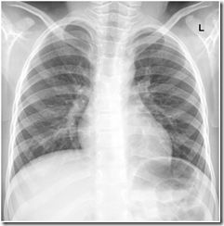
CXR source: http://radiology-information.blogspot.ca/2015/04/normal-chest-x-ray.html

Post-intubation - normal
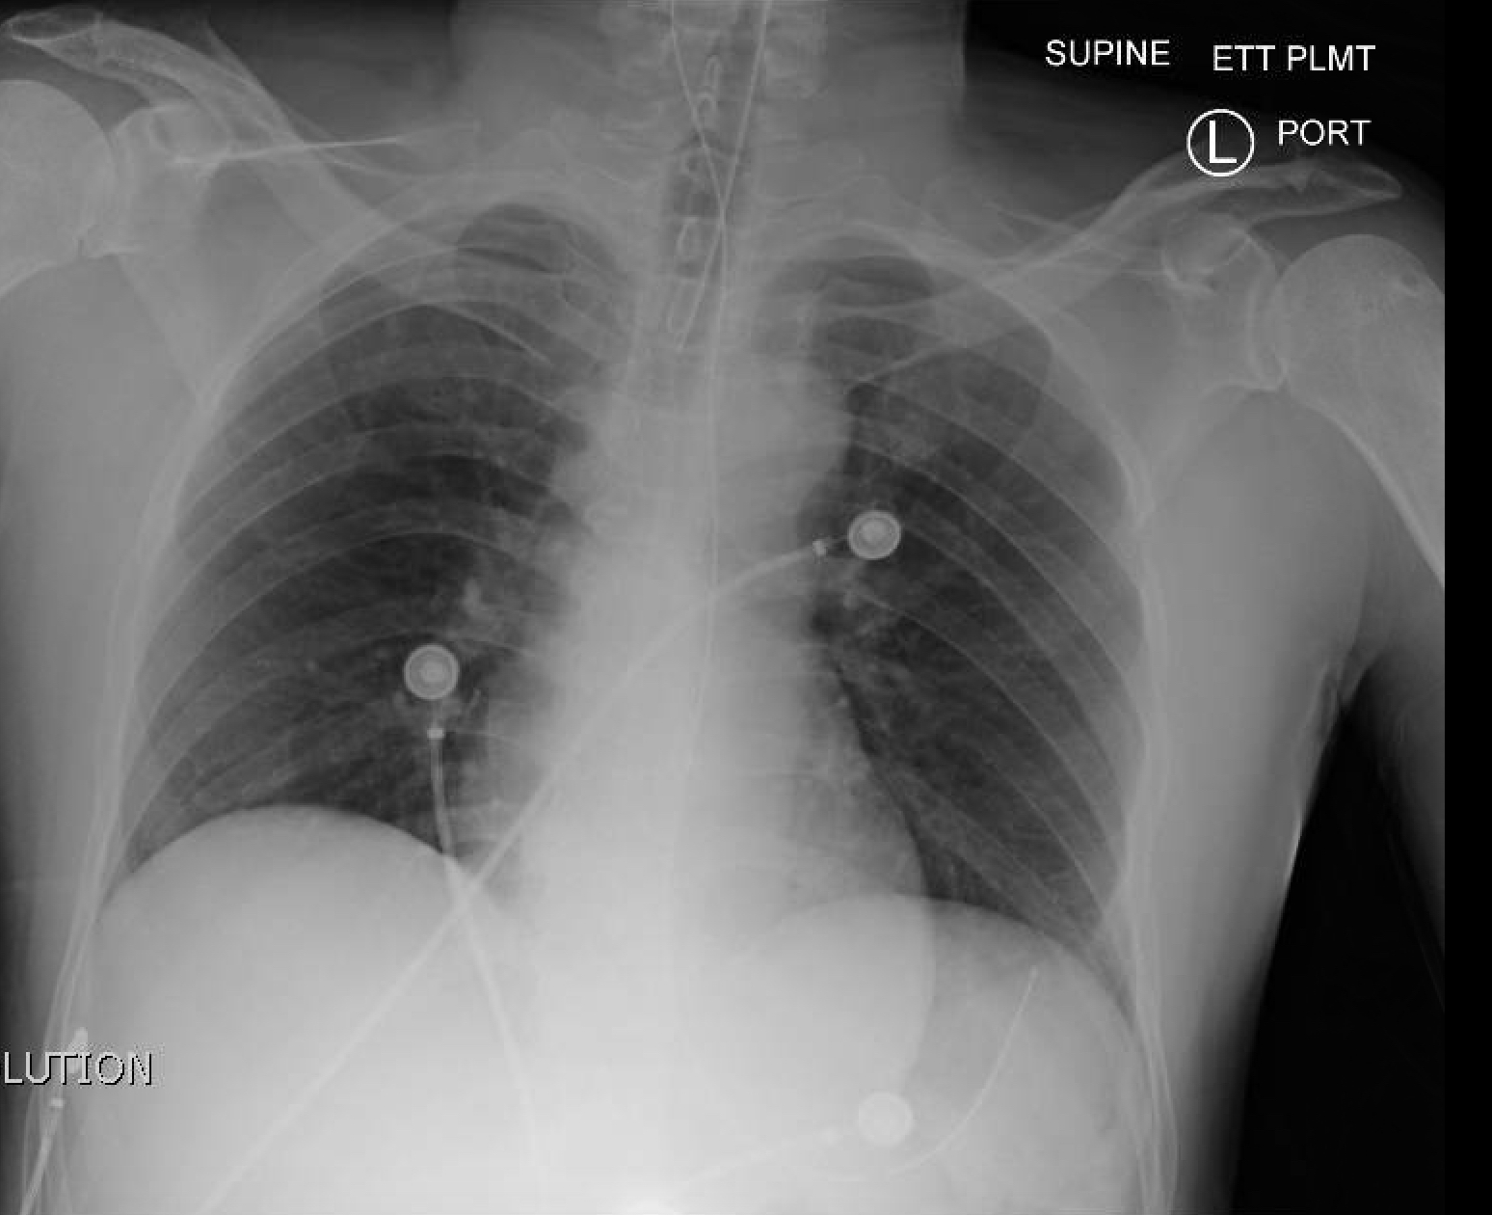
CXR source: http://jetem.org/ettcxr/

Appendix C: Facilitator Cheat Sheet & Debriefing Tips

Include key errors to watch for and common challenges with the case. List issues expected to be part of the debriefing discussion. Supplemental information regarding any relevant pathophysiology, guidelines, or management information that may be reviewed during debriefing should be provided for facilitators to have as a reference.

The debrief should be done as a group.

Sample Questions for Debriefing:
- When did you decide to start secondary treatments for asthma? What are their indications? How do you determine whether this is a severe exacerbation?
- What are the additional treatments (other than steroids and salbutamol) that are available for the treatment of severe asthma?
- What are the indications for intubation in asthma?
- What are your peri-intubation considerations?
- What is your approach to post-intubation hypotension/decompensation?
- What are the ventilation considerations after intubation in asthma patients?
- Why did this patient arrest? (If he arrested in the scenario)
- How did it feel as a team to manage this extremely unwell child that was not responding to the usual treatments that make most kids better? Do you feel you remained calm?

Key moments:
- Recognition and treatment of severe asthma
- Decision to intubate
- Recognition of post-intubation complications

References

1. O Ortiz-Alvarez, A Mikrogianakis; Managing the Patient with an acute asthma exacerbation. Canadian Paediatric Society,Paediatr Child Health 2012;17(5):251-5
2. Allen JY, Macia CG. The efficacy of ketamine in pediatric emergency department patients who present with acute severe asthma. Ann Emerg Med. 2005;46(1):43-50.
3. Mechanical Ventilation in Severe Asthma on Pediatric EM Morsels
4. Management of Life Threatening asthma in the ED First 10 in EM https://first10em.com/2015/08/18/asthma/
5. Management of Acute Pediatric Asthma Exacerbations EMCases https://emergencymedicinecases.com/pediatric-asthma/

